The Hong Kong Polytechnic University

EE3008A Linear Systems and Signal Processing

Department of Electrical Engineering

Lab 1: Bandwidth of copper wires and its dependence on length

Aim
To study the effect that varying lengths have on the system bandwidth.

Apparatus
- Signal Generator
- Oscilloscope
- 2x 600m coils
- 1x 1200m coil
- Crocodile clip/jumper wires
- BNC cables

Background
All signals traveling through any medium has some sort of effect imposed on them. For example, sound travelling through a long tunnel might not sound the same at both ends, or a packet of light travelling through a fibre optic cable might be different at the end. The transmission medium can be modelled as a linear and time invariant (LTI) system with transfer function. The effect of how each of the medium affect input signals can be understood as how the input signal spectrum is modified by to produce output spectrum as shown in the following figure.
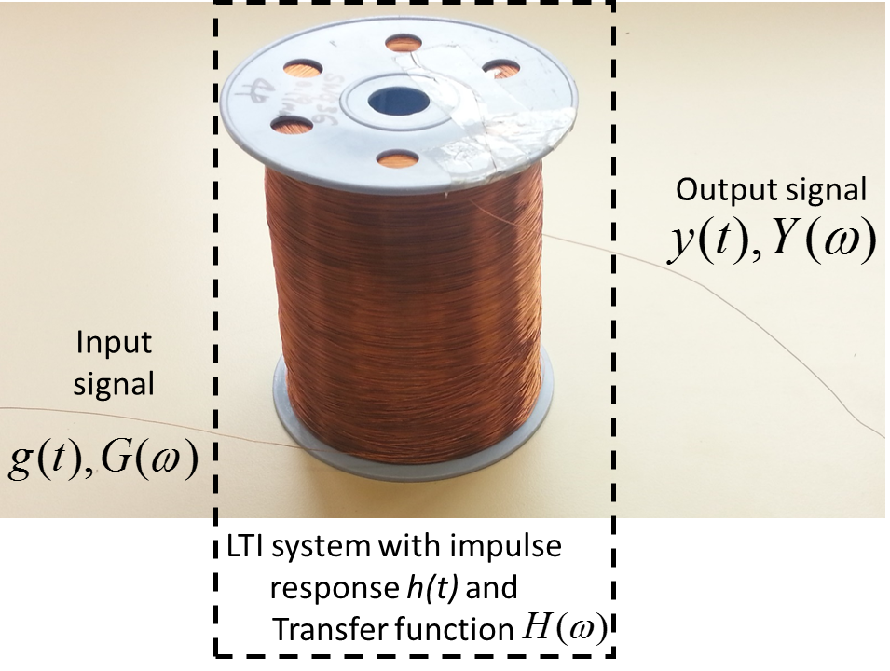
Figure 1: A piece of copper wire can be modelled as an LTI system with impulse response h(t) and corresponding transfer function.
In this lab, you will experimentally measure the transfer functionof a piece of electrical wire by comparing the amplitude and phase difference between input and output sinusoids at different frequencies. We will also investigate how the shape of the transfer function and bandwidth of the piece of wire depends on length.

Principle
We will experimentally measure the amplitude and phase of transfer function of at around 15 frequency points. In particular, we will use the signal generator to produce a sinusoid with frequencyas input signal. The signal will go through the piece of wire and produce the output signal. Now, since and , the output spectrum will be
(1)
Also, for LTI systems in real life, it is always true that i.e. and . Continuing from Eq. (1),
and the output signalis given by
Therefore, the output signal will also be another sinusoid with the same frequency but different amplitude and phase as shown in the following figure.
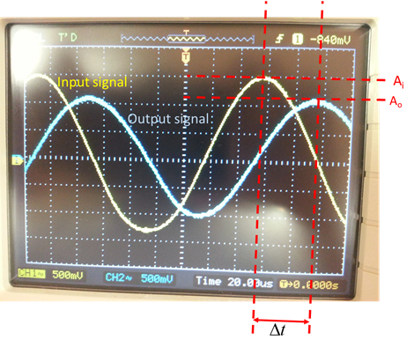
Figure 2: The input and output sinusoid with frequencyafter passing through a coil of electrical wires. The relative amplitude and phase difference can be used to estimate the transfer function.

With the input and output sinusoids obtained from our experiments, we can estimate the amplitude of the transfer functionatby taking the ratio of the input and output sinusoid amplitude i.e.
In addition, one can measure the relative time shiftof the output sinusoid and determine the phase response by
.
By repeating the above procedure for different frequencies, one can experimentally estimate the transfer functionof a piece of copper wire.
Experimental Procedure
- Connect your signal generator directly to the oscilloscope and set the voltage to 6V.
- Connect the signal generator to a 600-m coil then to the oscilloscope. This will be the input signal.
- Connect the other end of the coil to the oscilloscope. That will be the output signal $y(t)$.
- Starting from the lowest possible frequency of the signal generator, gradually increase the frequency towards the highest possible and look at the output signal amplitude to get a feel of how $|H(ω)|$ roughly varies with frequency. Fill out the following table by measuring the output amplitude and phase at the oscilloscope by changing the frequency of the signal generator, starting from 100 Hz, 200 Hz, 500 Hz, 1 kHz, 1.25kHz, 1.5kHz, 1.75kHz, 2kHz, 2.25kHz, 2.5kHz, 3kHz, 4kHz, 5kHz, 10kHz, 20 kHz (or you can add some more frequency points yourself to better capture the range in which $|H(ω)|$ changes a lot)
- Plot the spectrum (both phase and amplitude).
- Repeat steps 1 to 5 for 1200m (1200m coil) and 2400m (2x 600m and 1200m coil) and plot the corresponding spectrum. Taking PolyU as the center, the following figure shows the coverage area from PolyU for various lengths of wires we investigated in our lab.
- For the 2400 m coil, change the input to square wave at 3 MHz(or the highest frequency allowed by your signal generator). This waveform essentially corresponds to the bit sequence ‘101010101010…’ at 3 Mbits/s. Record the input and output signal from the oscilloscope.
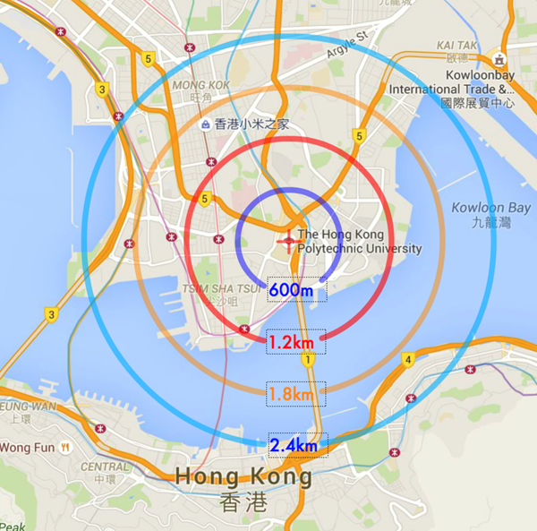
Figure 3: Coverage area from PolyU for various distances.
Questions
- How does the amplitude spectrum change when the length of wire increases?
- Where is the frequency that gives the highest amplitude spectrum?
- Is there a certain pattern for the phase spectrum as the distance increase?
- Can the ‘1’ and ‘0’ be recovered from the output signal after 2400 m transmissions at the highest bit rate possible by your signal generator?
- What does the result of this lab say about long distance signal transmissions?

Frequency $f(=ω/2π)$ (Hz) | Output signal Voltage  [Peak to Peak] |  | Amplitude spectrum $\left|H\left(f\right)\right|$ | Phase spectrum $∢H\left(f\right)$
100 |  |  | 1
200 |  |  | 1
500 |  |  | 1

